First project:

You will have to form a group of 3 to 4 students.

Choose a dataset from the UC Irvine Machine Learning Repository (https://archive.ics.uci.edu/ml/index.php) with at least 5000 instances and 20 attributes for classification or regression. Compare how the different approaches seen in class perform on this dataset to predict accurately the classes or the values of the unlabeled data. You should determine what are the best hyper-parameters for each approach you are using. You could use any Python libraries.

<https://archive.ics.uci.edu/dataset/534/wave+energy+converters>

**Wave Energy Converters**

This data set consists of positions and absorbed power outputs of wave energy converters (WECs) in four real wave scenarios from the southern coast of Australia.

**Attribute Information**

Additional Information

Attribute: Attribute Range

1. WECs position {X1, X2, â€¦, X16; Y1, Y2,â€¦, Y16} continuous from 0 to 566 (m).

2. WECs absorbed power: {P1, P2, â€¦, P16}

3. Total power output of the farm: Powerall

Data Source: The data is collected from real wave scenarios at four locations along the southern coast of Australia: Sydney, Adelaide, Perth, and Tasmania.

Number of WECs: There are 16 wave energy converter (WEC) locations considered in the study.

Size-Constrained Environment: These 16 WECs are optimized within a size-constrained environment. This means that there are limitations on the physical size or placement of the WECs.

papers:

<https://arxiv.org/ftp/arxiv/papers/2011/2011.13130.pdf>

<https://www.youtube.com/watch?v=4yHHF9goNqE>

Wave Farm

<https://www.youtube.com/watch?v=-XWbVMtNnaw>

CETO

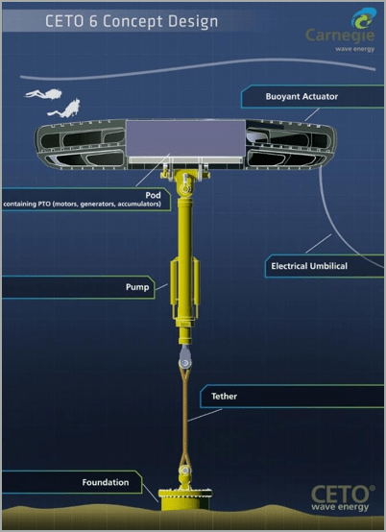

Pages: 5 - 8 pages

- include a presentation of the research questions

- the chosen methods to tackle them

- a presentation of the results and discussion and a conclusion/future work

- attach a description of the participation of each student to the project

Wave Energy Converters (WECs) convert wave power into electricity.